course syllabus

This course will follow and expand upon the New York State Regents Syllabus for Chemistry.
The core areas to be covered throughout the year include:
Topic 1: Introduction to Chemistry | Topic 8: Bonding
Topic 2: Atomic Structure | Topic 9: Solutions
Topic 3: Formulas and Equations | Topic 10: Kinetics and Equilibrium
Topic 4: Moles and Stoichiometry | Topic 11: Acids, Bases and Salts
Topic 5: Energy | Topic 12: Redox and Electrochemistry
Topic 6: Gases | Topic 13: Organic Chemistry
Topic 7: Periodic Table | Topic 14: Nuclear Chemistry

ACADEMIC & LABORATORY REQUIREMENTS

Course Materials:
- Class binder: Large viewfinder loose-leaf binder
- ***Lab Binder: 1 inch 3-ring soft binder***
- Physical Setting/CHEMISTRY Reference Tables
- Scientific Calculator (no graphing calculator allowed)
- Textbook (Reference text to be kept at home)

Grading Policy: Quarterly grades will be computed as follows:

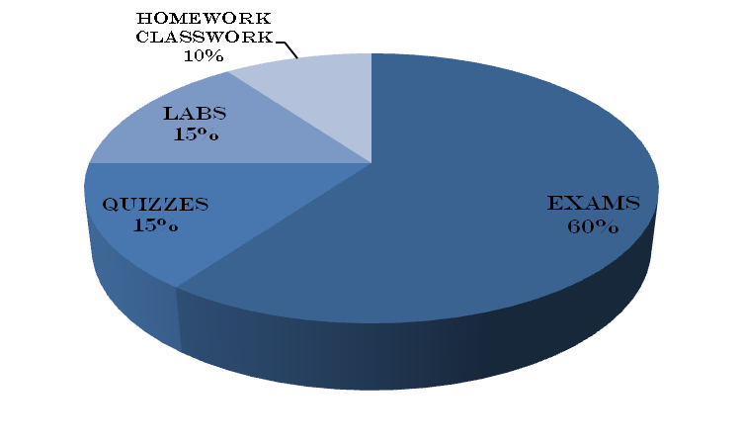
Exams | 60%
Quizzes | 15%
Labs | 15%
Homework/Classwork | 10%

EXAMS:
- Given after each major topic. Notice is given in advance.
- Graded on a scale of 0-100%. All exams will consist of two parts. Part A will be multiple choice questions and Part B will be a free-response section with a combination of short answers, essays and problem solving.
- Exam-corrections will be assigned for homework for each exam
- Cumulative exam will be given at the end of each quarter, with material going back to the beginning of the school year. It will be in the same format as a regular exam and graded on the same scale.
- A Midterm Exam will be given at the end of second quarter or the beginning of the third quarter. Material will be based on the first half of the school year and will clearly indicate your relative areas of strengths and weaknesses. This exam will count twice. A score below 70 on this examination will warrant assigned extra-help sessions.
- The course ends with the Regents Exam.
- Major exams will be given on the Science test day, which is Thursday.

QUIZZES:
- Announced or unannounced. Some may be open notebook. (Keep your notes neat and up to date at all times). Most quizzes consist of free-response type questions.
- Graded on a scale of 0-100%.
- Option of dropping one quiz per quarter is earned by each student by proper preparation and classroom behavior.

LABS:
- Handed in on day set by teacher.
- Must follow Lab Format and Lab Rubric as instructed in class.
- Late lab reports are penalized 5 points per day for three days, after which the grade is zero.
- All labs must be completed to satisfaction in order to take the NYS Regents exam in June.
***IMPORTANT – In order to take the Regents Exam at the end of the year you need a written record of a minimum of 1200 minutes of lab experience. This means that REGARDLESS OF THE GRADE that you will earn ALL LABS MUST GET TURNED IN.
HOMEWORK/CLASSWORK:
- Homework will be assigned on a regular basis in the form of worksheets and Castle Learning assignments.
- You are expected to submit your homework worksheets within the first 5 minutes of class.
- All written assignments will be checked for completeness. You are responsible for checking your homework and making corrections. Very often homework problems will appear on quizzes.
- If you are absent the day an assignment is due it is your responsibility to show me the assignment when you return.
- In order to avoid deductions all work must be shown for problems. Answers only will be counted as an incomplete homework!!!
- Half-credit for homework offered for assignments completed on the day after due, for hand-in assignments only (this does not include Castle Learning assignments).

Make-ups:
a. If you are absent from a quiz or test, yet know about it, you must take the exam the day you return.
b. If you had an extended absence, please see me to arrange a make-up day and time.
c. Illegal absence from an exam or quiz will result in a grade of ZERO AND a forfeiture of a make-up!
d. It is your responsibility as a student to initiate arrangements to make up labs, quizzes and exams.

Student assistance:
a. Students are encouraged to come to the Study Center, Room 210, any period of the day for
assistance. The study center is also available for extra help, check with them for availability and times.
b. Science Extra Help Day is on Wednesday afternoons until 3:15 in Room ________
c. Consistent poor performance on exams will necessitate an assignment to extra-help sessions the designated day for science. Failure to show for assigned extra-help will necessitate a parent conference.
it’s my pleasure to keep in touch with you!
Please feel free to Email sroozdar@greatneck.k12.ny.us!
www.Roozdar.weebly.com

